**PRACTICAL NO :8**

**CODE:**

**CREATE DYNAMIC WEB PROJECT IN ECLIPSE:**

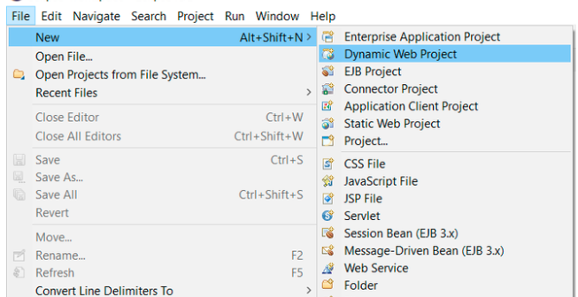

**DOWNLOAD STRUCT2 AND COPY THE LIBRARY FROM IT AND PASTE IN LIB FOLDER OF PROJECT**

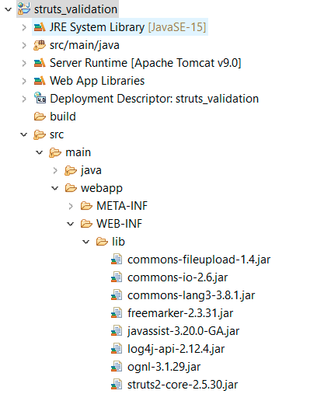

**XML FILE:**

<?xml version="1.0" encoding="UTF-8"?>

<web-app xmlns:xsi="http://www.w3.org/2001/XMLSchema-instance"

xmlns="http://xmlns.jcp.org/xml/ns/javaee"

xsi:schemaLocation="http://xmlns.jcp.org/xml/ns/javaee

http://xmlns.jcp.org/xml/ns/javaee/web-app_4_0.xsd"

id="WebApp_ID" version="4.0">

<display-name>struts_validation</display-name>

<welcome-file-list>

<welcome-file>index.jsp</welcome-file>

</welcome-file-list>

<filter>

<filter-name>struts2</filter-name>

<filter-class>org.apache.struts2.dispatcher.filter.StrutsPrepareAndExecuteFilter</filter-class>

</filter>

<filter-mapping>

<filter-name>struts2</filter-name>

<url-pattern>/*</url-pattern>

</filter-mapping>

</web-app>

**INDEX.JSP FILE:**

<%@ page language="java" contentType="text/html; charset=UTF-8"

pageEncoding="UTF-8"%>

<%@taglib uri="/struts-tags" prefix="s" %>

<!DOCTYPE html>

<html>

<head>

<meta charset="UTF-8">

<title>Login</title>

<s:head />

</head>

<body bgColor="lightGreen">

<s:form action="Login">

<s:textfield name="userName" label="User Name" placeholder="Default 'Sanjyot'"/>

<s:password name="password" label="Password" />

<s:textfield name="phoneNumber" label="Phone Number" placeholder="10 digit phone number"/>

<s:textfield name="email" label="Email" type="email" />

<s:submit value="Login" />

</s:form>

</body>

</html>

**WELCOME.JSP**

<%@ page language="java" contentType="text/html; charset=UTF-8"

pageEncoding="UTF-8"%>

<%@taglib uri="/struts-tags" prefix="s" %>

<!DOCTYPE html>

<html>

<head>

<meta charset="UTF-8">

<title>Login Successful</title>

</head>

<body>

<h3> Congratulations! You have logged in successfully.</h3>

<h4> Welcome <s:property value="userName"/>!!! </h4>

</body>

**LOGIN.JAVA**

package com.SanjyotPanure.struts2;

import com.opensymphony.xwork2.ActionSupport;

public class Login extends ActionSupport {

private String userName;

private String password;

private String phoneNumber;

private String email;

public String execute() {

return SUCCESS;

}

public String getUserName() {

return userName;

}

public void setUserName(String userName) {

this.userName = userName;

}

public String getPassword() {

return password;

}

public void setPassword(String password) {

this.password = password;

}

public String getPhoneNumber() {

return phoneNumber;

}

public void setPhoneNumber(String phoneNumber) {

this.phoneNumber = phoneNumber;

}

public String getEmail() {

return email;

}

public void setEmail(String email) {

this.email = email;

}

public void validate() {

if (getUserName().length() == 0) {

addFieldError("userName", "UserName is required");

}

else if (!getUserName().equals("Sanjyot")) {

addFieldError("userName", "Invalid User");

}

if (getPassword().length() == 0) {

addFieldError("password", getText("Password is required"));

}

if (getPhoneNumber().length() == 0) {

addFieldError("phoneNumber", getText("Phone Number is required"));

}

else if (!(getPhoneNumber().length() == 10)) {

addFieldError("phoneNumber", "Enter 10 digit phone number");

}

if (getEmail().length() == 0) {

addFieldError("email", getText("Email is required"));

}

}

}

**STRUCT.XML**

<?xml version="1.0" encoding="UTF-8"?>

<!DOCTYPE struts PUBLIC

"-//Apache Software Foundation//DTD Struts Configuration 2.0//EN"

"http://struts.apache.org/dtds/struts-2.0.dtd">

<struts>

<constant name="struts.custom.i18n.resources" value="LoginAction" />

<package name="default" extends="struts-default" namespace="/">

<action name="Login" class="com.SanjyotPanure.struts2.Login" >

<result name="success">welcome.jsp</result>

<result name="input">index.jsp</result>

</action>

</package>

</struts>

**OUTPUT:**

